***Day 2 – Task 1 – August 8, 2022.***

***Difference between Window object and document object in JavaScript***

***Window Object:***

Window is the main JavaScript object root or the global object in a browser, and it can also be treated as the root of the document object model. It could be accessed as window.

***Document Object:***

Document is the main object of the potentially visible document object model/DOM. It has to be accessed as window.document.

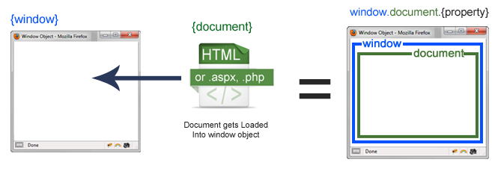

|  |  |
| --- | --- |
| **Window Object** | **Document object** |
| Top of the hierarchy. It is the outmost element of the object hierarchy. | Each HTML document that gets loaded into a window becomes a document object. The document contains the contents of the page. |
| It is the very first object that is loaded in the browser. | It is loaded inside the window. |
| It is the object of the browser. | It is the object of window property. |
| All the global variables are defined on the window object.  For example,  alert(), confirm() are methods defined on the window object. | document object has many useful methods defined on it.  For example,  document.getElementById(), document.getElementByTagName(), document.createElement(), document.querySelector() and many more |
| Properties of the window object cannot be accessed by the document object. | Properties of document objects such as title, body, cookies, etc can also be accessed by a window like this window. document.title |
| syntax:window.propertyname; | syntax:document.propertyname; |
| example: window.innerHeight : will return the height of the content area of the browser | example: document.title : will return the title of the document |